A Report On

**BLUETOOTH BASED SONSOR NETWORK**

Submitted in partial fulfilment of the requirements of the degree of

**(Internet of Things and Cyber Security Including Block Chain Technology)**

**2022-23**

**SUBMITTED BY -**

|  |  |
| --- | --- |
| ***Priyush B. Khobragade*** | **52** |
| ***AKSHAY LOHAR*** | **57** |
| ***AYUSHI MASKE*** | **15** |
| ***KAUSTUBH DHAKATE*** | **72** |



Department of Computer Science and Engineering (Internet of Things and Cyber Security Including Block Chain Technology)

A. C. Patil College of Engineering, Kharghar, Navi Mumbai University of Mumbai

2021-2022

|  |
| --- |
|  |

|  |
| --- |
|  |

Jawahar Education Society’s

A. C. Patil College of Engineering, Kharghar

CERTIFICATE

This is to certify that the Project entitled

“**BLUETOOTH BASED SONSOR NETWORK**”

is a bonafide work of

Submitted to the University of Mumbai in partial fulfilment of the requirement for the award of the degree of Second Year Engineering in Computer Science and Engineering (Internet of Things and Cyber Security Including Block Chain Technology)

**(Prof. Ulka Shirole) Prof. S. P. Pawar**

Guide Head of Department

**Dr.V.N. Pawar**

**DECLARATION**

We affirm that the title **“BLUETOOTH BASED SONSOR NETWORK”.** Begin submitted in partial fulfillment for the award of Bachelor of Engineering in Computer Science and Engineering is the original work carried out by me. It has not forwarded the part of any other thesis submitted for award of any degree or diploma, either in this or any other University.

**Signature of the candidate:-**

|  |  |
| --- | --- |
| PRIYUSH KHOBRAGADE | 52 |
| AKSHAY LOHAR | 54 |
| AYUSHI MASKE | 15 |
| KAUSTUBH |  |

I certify that the declaration made above by the candidate is true.

Signature of the Guide,

PROF.ANAND KUMAR, CSE(IOT),

**ACKNOWLEDGEMENT**

We express my sincere gratitude to the people who extended their help during the course of this project work.

We greatly and profoundly thankful to our honorable **CHAIRMAN Lion C.SUBRAMANIAN** for giving motivation and providing all necessary facilities for the successful completion of this project.

We greatly and profoundly thankful to our honorable **SECRETARY Ms. J.S.GAYATHRI, BE, MBA** for offering the facilities and encouragement to complete the project successfully.

We also record my sincere thanks to beloved **PRINCIPAL**  D**r.S.VENKATESAN, B.E, MBA, M.E.,Ph.D.,** for their moral support and deeds in bringing out this project successfully.

We thankful and extremely grateful to **HEAD OF THE DEPARTMENT Mrs.M.R.SATHYA, B.Tech, M.E., B.ED., Professor, Computer Science and Engineering** **Department** for her moral support.

We also thank **Mr.S.VETRIVEL, M.E., Assistant Professor, Department of Computer Science and Engineering**, who done the role of guide in each step of our project and for her guidance and constant support in the successful completion and improvement of the project.

We also thankful to all the faculty members of **Department of Computer Science and Engineering** for their kind and valuable cooperation during the course of the project.

We would also like to thank my **parents, friends and well-wishers** who encouraged me to do the project.

Report Approval

This Report entitled “**“BLUETOOTH BASED SONSOR NETWORK”.”** by **Priyush B. khobragade (52.), Lohar Akshay Suresh(54), Ayushi Maske(15), Kaustubh () for** the course **PCE** is approved for the degree of **THRED Year Engineering** in **Computer Science and Engineering (Internet of Things and Cyber Security Including Block Chain Technology)**

**Examiners**

**1………………………………………**

(Internal Examiner Name & Sign)

**2…………………………………………**

(External Examiner name & Sign)

Date: Place:

**BLUETOOTH BASED SMART SENSOR NETWORKS**

**Abstract:**

Wireless sensor networks are networks of small computers, fitted with sensors, microprocessors and wireless interfaces. This technology has achieved a lot of attention lately. For these networks are suggested the wide range of modern and fascinating applications, from personal health care to environmental monitoring and military applications. Different wireless technologies, such as simple RF, Bluetooth, UWB or infrared, may be used to communicate between sensors.

The core concepts, features and problems of Bluetooth-based wireless sensor networks are outlined in this, as well as the execution of a simple Bluetooth-based sensor network.

The presentation of main problems experienced during the implementation and applied solutions are also done. This is specified on the smart sensor networks using the Bluetooth topology. How smart sensor networks are used and can be implemented using the Bluetooth technology. How they are used as the purpose of communication in industrial field, how they are built, their working and concept is reviewed. Architecture, network, applications and working has been reviewed basically for the communication and research purpose.

# INTRODUCTION :

Wireless sensor networks are networks of small devices having sensors, microprocessors and wireless communication interfaces. This technology has become famous lately. For the purpose of communication in industrial field, WSN technology is widely used. Sensors are used for the communication in industries. In this process, the signals are send through the wires from each field devices and are monitored on central control room. With the beginning of wiring concept, the field device is used for minimizing the wiring cost. Wireless technology is introduced to eliminate the wires as they are costly, bulky and can be easily damaged.

Ericsson Mobile communications started a research to explore the usefulness of a consuming low power, low cost, low ratio interface, and to find a process to remove wires between the devices in the year 1994. Then the Bluetooth technology was invented by an electrical engineer Dr. Jaap Haartsen and named the technology Bluetooth to the honor of the 10th century king Harald “Blue tooth” of Denmark. The aim of Bluetooth is harmony and unification [6]. It also enables the different devices to communicate through wireless connectivity. Bluetooth uses frequency hopping spread spectrum technique and works in the illicit ISM band at 2.4 GHz frequency. A distinctive quality Bluetooth device holds a range of about 10 meters and can be extended to 100 meters. Bluetooth is wireless high speed data transfer technology over a short range (10 − 100 meters).

* **Bluetooth Wireless Technology (BWT)** was developed in 1994 at Ericsson in Sweden.
* **Purpose** − Originally it was build to eliminate the need for cable connections between PDAs and notebook PCs. Later the goals were to enable different devices through a commonly accepted standard for wireless connectivity.
* Ericsson on advent of BWT conceptualized a Radio Technology through a **wireless personal area network (WPAN)***.*

# 1.2 BLUETOOTH SPECIFICATIONS

#### Bluetooth Specifications are:

* Developed by: *Jaap Haarsten* and *Sven Mattisson* in Sweden
* Standard: IEEE 802.15
* ISM Band Frequency: 2.4 GHz
* Range: 10 − 100 meters
* Channel Bandwidth: 1 Mbps
* Maximum Asymmetric Data Transfer Rate: 721 Kbps

**Why the name** **BLUETOOTH**?

The name was adopted as a tribute to the tenth−century Viking king Harald Blåtand who peacefully united Denmark and Norway. Harald liked to eat blueberries, which gave his teeth the coloration that led to the nickname "Bluetooth."

# 1.3 TYPES OF BLUETOOTH

Depending on the *power consumption* and *range* of the device, there are 3 Bluetooth Classes as:

* **Class 1**: Max Power − 100mW ; Range − 100 m
* **Class 2**: Max Power − 2.5mW ; Range − 10 m
* **Class 3**: Max Power − 1mW; Range − 1 m

# 1.4 BLUETOOTH OPERATIONS :

* BWT− enabled devices operate in 2.4GHz ISM Band (Industrial, Science, Medical band).
* It uses 79 1−MHz frequencies in the ISM Band.
* Technique used − *frequency hopping,* to minimize interference from other networks that also use ISM Band.

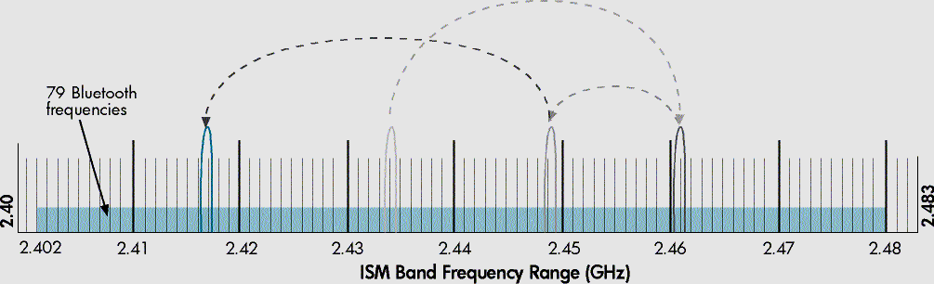

**Figure** : BWT−enabled devices hop between frequencies up to 1600 times per second.

**HOW TO REDUCE INTERFERENCE?**

* BWT devices hop randomly between frequencies up to 1600 times per second.
* So, if another device using a 2.4 GHz frequency (e.g.: cordless phone) ,then the interference with the BWT network lasts only for about 1/1600 of a second.
* By then, the devices hop to another frequency.
* High Immunity to interference from other 2.4 GHz devices.

**2.1 TECHNOLOGY:**

## 2.1 TECHNOLOGY OVERVIEW:

Bluetooth is low priced, short range wireless technology with small power utilization and suitable for diverse small battery driven devices like mobile phones, cameras, laptops, etc. There are two topologies used in Bluetooth architecture: Piconet and Scatter net.

# 2.2 BLUETOOTH TOPOLOGY

# Depending on the type of connections established between various Bluetooth devices, 2 main topologies are as:

* + - 1. PICONET TOPOLOGY, and
      2. SCATTERNET TOPOLOGY

To any topology, there are 2 prime components:

1. MASTER device
2. SLAVE device

**2.3 A Piconet:**

A *piconet* consists of up to 8 BWT−enabled devices.

When *piconet* is established, one device sets up *frequency− hopping pattern* and other devices synchronize their signals to the same pattern.

Primary Devices: Those devices which sets the frequency−hopping pattern.

Secondary Devices: Those devices which get synchronized. Each *piconet* has a different frequency−hopping pattern.

In Bluetooth, each *piconet* has 1 Master for establishment of piconet, and up to 7 Slave devices.

Master’s Bluetooth address is used for defining frequency− hopping sequence.

Slave devices use master clock to synchronize their clocks so as to hop simultaneously.

For establishing *piconet*, other Bluetooth devices in range are discovered by an inquiry procedure.

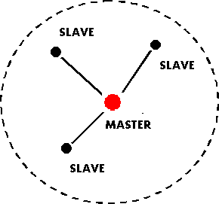

It is an improvised network used to link wireless devices using Bluetooth technology. It is group of up to 8 devices that shares similar frequencies. It uses the concept of master and slave. Each piconet has one master and rest of the device acts as slave. Usually, the device that starts off the piconet behaves as master. To establish a piconet, first the device searches for the other Bluetooth devices in the range. When the two devices have same frequency then required information is exchanged and to establish the connection paging procedure can be used. For more than 7 devices need to exchange information, there are two possibilities:

The initial one is by putting one or more devices into park state. The modes used in Bluetooth are sniff, hold and park which are used for low power consumptions [7]. When a device changes to the park mode then it disconnects from Piconet, but schedule adjustment will be maintained. The master of piconet continuously transmits signals to invite the slaves to retain the piconet. If there are less than 7 slave devices in the piconet then only the slave will rejoin. If not then one of the active slave devices will be park by the master. Due to these actions, there will be delay and it can be undesirable for some applications like procedure control applications that need instant reply from the command center.

# 2.4 BT NODES:

The BT nodes were developed by ETH Zurich in the con- text of the Smart-Its project. They are based on the Atmel ATmega128L microcontroller - an 8-bit microcin- troller (MCU) clocked at 7.4 MHz, with 4 KiB1 on chip memory and an external memory chip of up to 64 KiB. The MCU has digital and analog I/O ports that can be used to connect external sensor devices through Molex plugs on the edge of the board. The nodes are equipped with a Bluetooth module (Ericsson ROK 101 007) together with an onboard antenna. Two UARTs connect the MCU with the embedded Bluetooth chip and one of the Molex plugs. Four lads can be used for debugging purposes. The board also contains a voltage regulator: the BT node can be plugged to power supplies ranging from 3.3 V to 12 V.

|  |  |
| --- | --- |
| MCU | Atmel ATmega128L at 7.372 MHz |
| Memory | Built in: 128 KiB Flash, 4 KiB SRAM  4 KiB EEPROM  External: 64 KiB RAM |
| I/O | 8 Channel 10-bit A/D-converter  2 programmable serial UARTS |
| Embedded  Radio | Ericsson ROK 101 007 |
| External  Radio | BTTester  (Ericsson ROK 101 007) |

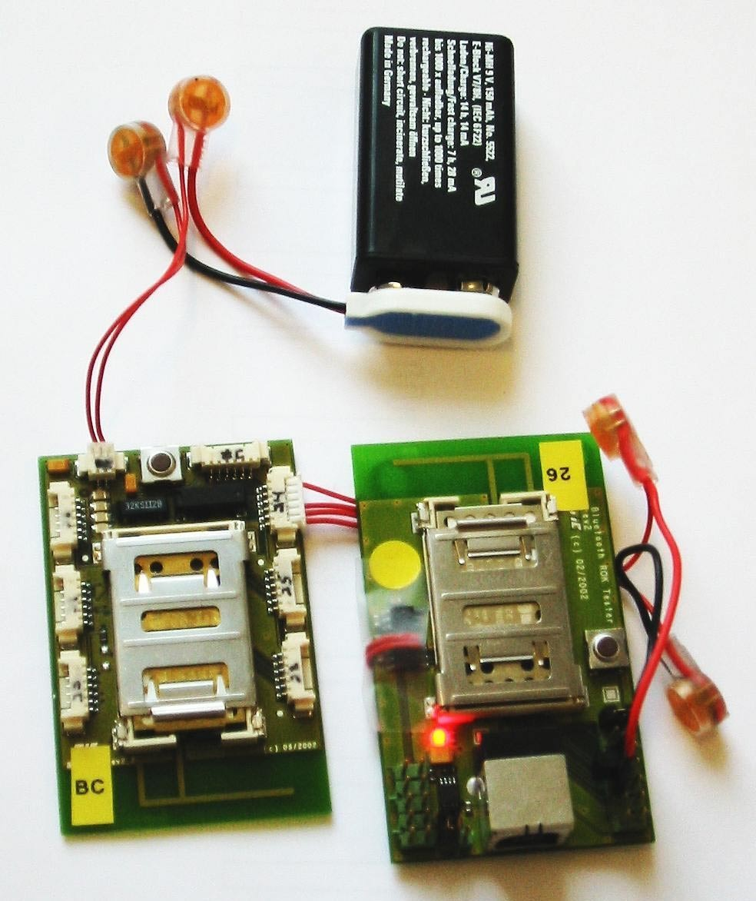

### Figure 2. 1: BT nodes characteristics

As explained in the Introduction, we used dual-radio nodes for our experiments in order to assemble a multi hop network.

1EIC standard 60027-2 deﬁnes KiB as 1024 bytes .

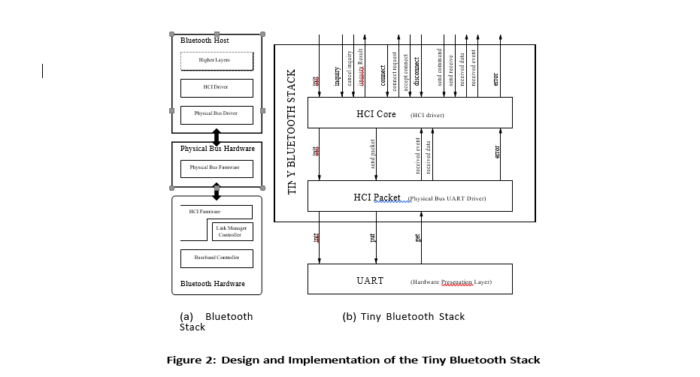

We thus connected an extra Bluetooth module to the BT- node (via the Molex plug connected to an UART). For this purpose, we used the BT tester (also from ETH Zurich), a serial dongle based on the ROK 101 007 Ericsson chip (in- clouding an onboard antenna and a monitoring led).

Figure 1 summarizes the characteristics of the BT nodes. Further documentation can be obtained on the BT node proj- ect page [5].

The Bluetooth speciﬁcation deﬁnes two software layers abstracting the higher layers from the hardware character- istics:

* 1. **Physical Bus Driver**: This layer abstracts the char- act eristics of the physical bus; on the BT nodes the UART connecting the MCU and the Bluetooth radio.
  2. **HCI Driver**: This layer maps the interface of the underlying HCI layer (the upper layer embedded on the Bluetooth radio) into the programming model used for implementing the higher layers.

# 3.1TINY BLUETOOTH STACK

In this section, we report on the design and implemen- tation of our Tiny Bluetooth stack. We compare it to the ETH Bluetooth stack for the BTnodes and to existing com- munication stacks developed for TinyOS.

# 3.1 Design

Our goal with the Tiny Bluetooth stack was to make it possible for TinyOS programs2 to access a Bluetooth radio. We could reuse most existing components of TinyOS except of course those abstracting hardware elements deferential- Ing the BTnodes from the Mica and Rene motes, e.g., the arts, the led, and the clock. We are not interested in implementing a full-ﬂedged Blue- tooth stack: while the three lower timing sensitive layers are embedded within the radio modules and thus a given, the higher computation intensive layers (l2cap, sdp, proﬁles) are essentially dealing with the connection of heterogeneous devices (e.g., a mobile phone and a headset) without provide- ing solutions to problems such as cross layer optimizations or multihop routing, which characterize the sensor network regime. The ability to connect to heterogenous devices is not of paramount interest in sensor networks, which are composed of sensor nodes tailored to operate together as one unit. We thus decided not to implement those three higher layers. Rather, we focus the Tiny Bluetooth stack on the interface to the Bluetooth hardware and its mapping to TinyOS. Network assembly and multihop routing are imple- minted on top of the Tiny Bluetooth stack.

The Bluetooth speciﬁcation distinguishes the *Bluetooth host*, on which the three upper layers of the protocol are im- plummeted from the *Bluetooth hardware* on which the three lower layers are implemented. The host and the hardware are connected via a physical bus (e.g., USB, UART, RS232). Figure 2(a) illustrates the connection of the Bluetooth host and the Bluetooth hardware.

Our design is based on these hardware abstraction layers. The Tiny Bluetooth stack is composed of two components: *HCI Packet* that corresponds to the physical bus driver and *HCI Core* that corresponds to the HCI driver. The interfaces of both components are described in Figure 2(b) (we omit the events associated to each TinyOS command according to the asynchronous programming model).

TinyOS applications access the HCI Core component to communicate via Bluetooth. The HCI Core component sup- ports the main HCI commands related to (i) the initialize tion of the Bluetooth radio, (ii) the inquiries used for device discovery, (iii) the connection establishment, (iv) the trans- mission of data and (v) the reporting of errors. It relies on the services of the HCI Packet layer that maps send com- mands and receive events onto the UART component (a native TinyOS component slightly modiﬁed for the BTnodes). We detail below the implementation of these components.

#### Piconet Topology (Modes of Bluetooth Communication):

* When more than 7 devices need to communicate, then one or more devices are put in *park* state.
* 3 Bluetooth Low Power Modes are: *SNIFF, HOLD* and *PARK.*
* Park Mode: A devices disassociates from *piconet* when in park mode.
* The master consistently sends warnings to invite a slave to rejoin the *piconet.*
* The slaves can rejoin only if there a less than 7 slaves.
* 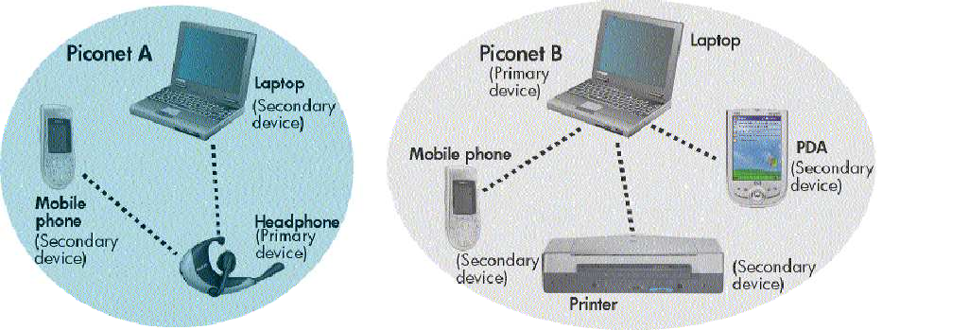If not so, the master has to ‘park’ one of the active slaves

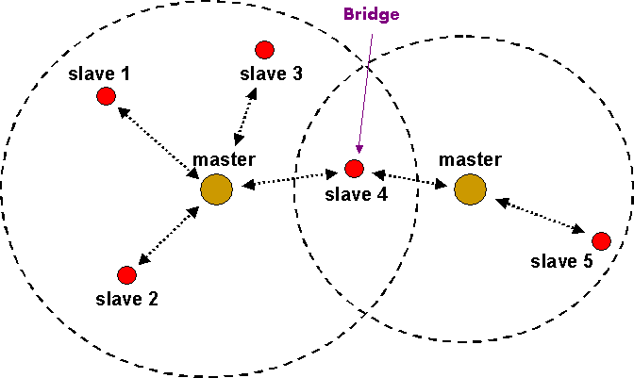**Scatternet** :

It is composed of interconnected piconets that maintain communication between more than 8 devices. Scatternets are formed when a device of one piconet that can be master or slave choose to act as a slave in second another piconet [7]. Scatternets provide higher throughput. Also in different piconets multiple-hop routing between devices is possible. That means at one time only single component can interface in one piconet so they hop from one to another relying upon the channel limit *Scatternet* consists of several *piconets* connected by devices participating in multiple *piconet.* Here, devices can be slaves in all *piconets* or master in one *piconet* and slave in other *piconets.* There is a ‘BRIDGE’ connecting 2 *piconets* which is also a slave in individual *piconets.*

**Advantages of *Scatternet*:**

* Higher throughput
* 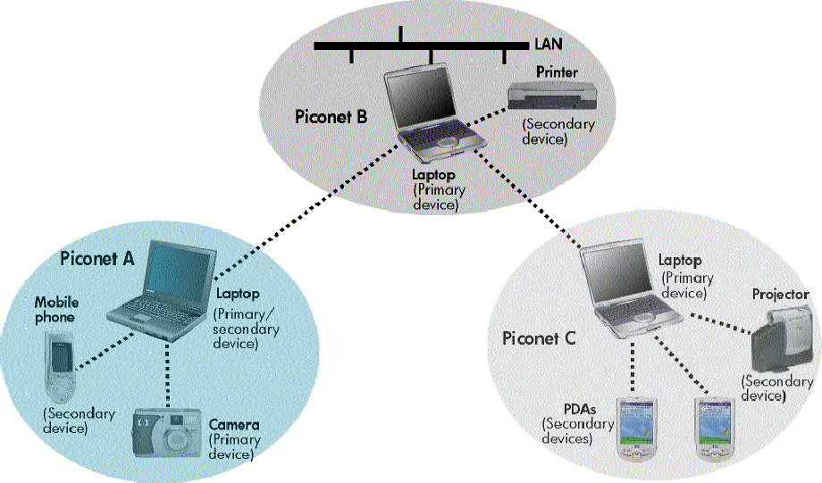Multi−hop connections between devices in different *piconets.*

**Fig1. A Scatternet**

# 3.2 BLUE TOOTH BASED SENSOR NETWORK

To produce different countless applications the developers are proving operability between different devices. Wireless sensor networks are example of such applications. It has various small devices consisting of sensing unit, microprocessor, power source and wireless communication bond. Important features of wireless sensor networks:

1. During the task in process network nodes combines with each other.
2. It has a particular attention on data.

As the position of junctions is not decided in the field and formation of smart sensor nodes is not planned it could be experienced that some sensor nodes close in such positions that they either can accomplish needed measurement or the error probability is more .To overcome these problems a small node of repetitive number is disposed. These nodes additionally merge and share data. And thus, ensures better outcomes. The collected data is sent to the users by “gateway” using multiple hop routes in the Smart sensor nodes that are scattered.

# 3.3 FUTURE OF BLUETOOTH:

* **BROADCAST CHANNELS:** Adoption of Bluetooth into mobile phones and enable advertising models based on users pulling information from the information points.
* **TOPOLOGY MANAGEMENT:** Automatic configuration of piconet topologies in scatternet situations.
* **QoS IMPROVEMENTS:** Enable audio and video data transmission at higher quality, especially in best effort traffic being transmitted in the same piconet.

# 4 .0 BWT SECURITY

BWT security is complex, transparent, and easily implemented BWT uses 3 security mechanisms: ***authentication, authorization*** and ***encryption****.*

3 levels (modes) security are:

##### **MODE 1: No Security**:

anyone can use the device; default setting condition in printers, etc.

##### **MODE 2: Service Level Security:**

permission required to access the device; exchange of business cards; personal authentication.

##### **MODE 3: Link Level Security:**

devices to be paired before connection and transfer

.

## BLUETOOTH HARDWAE ARCHITECTURE

Bluetooth hardware has 3 prime function modules:

* + 1. 2.4 GHz Bluetooth radio frequency Trans receiver unit.
    2. Link controlling unit
    3. Host controller interface

Host controller is made up of a digital signal processing section with link controller and central processor. Link controller composed of both hardware and software parts for the execution of base band processing and physical layer protocols. CPU core helps Bluetooth module to filter page request and to handle enquiries [4]. Link manager is software which runs on the CPU and communicates to them with the help of link manager protocols.

**HOST CONTROLLER –**

Consists of a *Digital Signal Processing* part, having *Link Controller(LC) & CPU Core.* It interfaces to the Host environment.

**LINK CONTROLLER −**

Consists of *Hardware & Software parts* to perform Base−Band Processing, and Physical Layer Protocols. Also performs low−level digital signal processing to form connections.

* **CPU CORE** − Helps Bluetooth Module to handle Inquires and filter page request (not involving host device).
* **LINK MANAGER** − LM software runs on CPU core. LM discovers other remote LMs and communicates to them via LMP (link manager protocols).
* Bluetooth Module also incorporates Higher−Level Software Protocols, governing the functionality and interoperability with other modules.

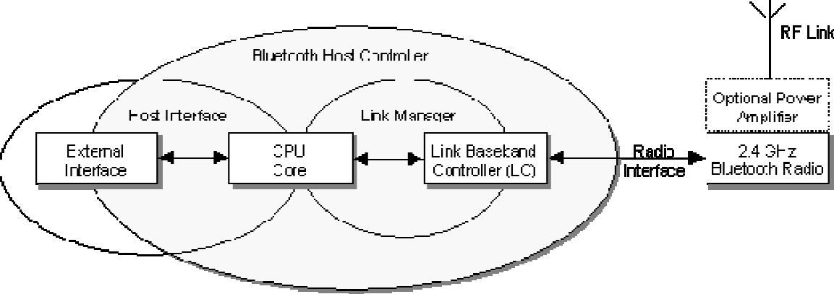

**Figure:** BL

Host controller is made up of a digital signal processing section with link controller and central processor. Link controller composed of both hardware and software parts for the execution of base band processing and physical layer protocols. CPU core helps Bluetooth module to filter page request and to handle enquiries .Link manager is software which runs on the CPU and communicates to them with the help of link manager protocols.

# 4.2 MULTIHOP NETWORK ASSEMBLY

Generic Packet Type (gen packet) and Example of a Speciﬁc Packet Type. The generic packet type deﬁnes a buﬀer together with start and end pointers. The speciﬁc packet type, sniﬀ mode packet, is used for sending the HCI command that turns a connection into the power saving sniﬀ mode. This speciﬁc packet type deﬁnes a buﬀer of the same size as the generic packet but more structured (the buﬀer is composed of an array of integers – meant to store a packet header – to which is concatenated a variable of type sniﬀ mode cp– that contains the HCI command deﬁnition and its arguments). The start pointer is of type sniﬀ mode cp so that a header can easily be added. form of multihop routing can be established (e.g., a routing tree for TinyDB as discussed in the next section).

# Design

We must take into account the following characteristics of our platform when designing a multihop network assembly procedure:

* + - 1. *Bluetooth Connection Establishment*. Bluetooth connection are established between a master and a slave. The assembly procedure must establish the role of each node with respect to a connection. Note that nodes cannot exchange information before they have established a connection. In addition, slaves cannot com- muricate with other slaves or overhear the communication taking place on other connections. As a result, we cannot use protocols involving spontaneous communication among neighbor nodes.
      2. *Dual Radio Approach*. There are three possible con- ﬁgurations for each dual-radio node: (i) a node can be connected as slave on its two radios, (ii) a node can be connected as slave on one radio and as master with up to seven connections on the other radio, or (iii) a node can be connected as master with up to seven connections on both its radios.
      3. *Device Discovery Protocol*. In order for two devices to discover each other, they must be in two complementary states at the same time: *Inquiry* and *inquiry scan*. The inquiring device continuously sends out *is anybody out there* messages hoping that these messages (known as ID packets) will collide with a device performing an inquiry scan. To conserve power a device wanting to be discovered usually enters inquiry scan periodically and only for a short time known as the inquiry window. During this period, the device listens for inquiry messages.

**The main challenges for the assembly procedure are thus**

1. to pick up pairs of nodes that should be connected and
2. to decide the attribution of slave and master for each connection.

A second approach consists in conﬁguring each node *a priori*. Each node is conﬁgured with a radio operating as a master and the other operating as a slave. This obliterates the need for the discovery and information exchange phases from the ﬁrst approach. The second approach constitutes a baseline. We chose to implement it on top of our Tiny Bluetooth stack.

Our baseline solution, inspired by Blue Tree (discussed below), is the following. When a node boots up, it enables one of its radios (the *slave* radio) and starts looking for an- to connect to. In this stage, the node will not be discoverable/visible for other nodes; it considers itself an orphan looking for a network. If it discovers other nodes, it tries to connect to one of them as a slave4. If the connection succeeds, it will consider itself member of the network, and turn on its other radio (the *master* radio), making it discoverable and ready to accept connections from nodes that are not currently members of the network.

If the connection as a slave fails, it is because the master has reached its limit on the number of connections it can accept (recall that a master can connect to seven slaves). The node then tries to connect to one of the other nodes it has found in its vicinity. If there is no such other nodes ready to accept a connection then the node tries to connect again to the ﬁrst node it contacted. If a master connected to seven slaves receives three repeated connection requests from the same node *N,* then it disconnects one of its slaves and accepts the connection from the node *N.* It has been shown that when a master is connected to more than ﬁve slaves, additional slaves are in connection range with at least one of the connected slaves. As a consequence, it is probable that the disconnected node will ﬁnd a node that it can connect to in its vicinity.

In order to bootstrap the assembly procedure, one of the nodes, say a gateway, starts-up with its *master* radio turned on, thus being discoverable for other nodes. Its *slave* remains disabled, or is used to connect to the *external world*. The network topology obtained with this assembly procedure is a tree, that we call a **connection tree**, rooted at the gateway node that starts-up the assembly procedure. Note that if we assume that all nodes start-up with their slave radio enabled, then the connection tree will be bushy: once a node activates its master radio, all nodes in its vicinity will have a chance to connect to it before they get a chance to connect to its children.

It is desirable that a sensor network be accessible via several gateways. One has a privileged role as the root of the connection tree. Other gateways are connected as leaves (they do not activate their master radio once they are connected to the network via their slave radio). If the root of the connection tree fails, then all the nodes disconnect and the assembly procedure can restart with another gateway taking the responsibility of being root of the connection tree

# Related Work:

Sohrabi et al. describe two assembly procedures for the Sensoria dual-radio nodes (equipped with proprietary frequency hopping radios). The ﬁrst procedure proceeds as follows: the two radios of a node are tuned to two ﬁxed channels. During network assembly, messages are exchanged on those channels to form clusters (in each cluster a node is elected as a master while the other nodes are slaves). The constraint that a node cannot be master on its two radios ensures that the clusters constructed for the two radios are diﬀerent. Such overlapping clusters cover the entire network with a high probability; but there is no control over the topology of the connection tree. The second procedure relies on a discovery phase during which one of the radios is tuned to a control channel in order to broadcast information. Once a node has received information about its neighbors it takes a decision on its own role: a master remains tuned to the control channel and exchange data to its slaves on its second radio while a slave exchanges data on both its radios. Both procedures rely on tuning one or both radios onto a ﬁxed channel so that nodes can broadcast information to their neighbors. This is not possible with Bluetooth.

Basagni et al. [20, 2, 13] proposed a set of scatternet formation protocols for Bluetooth devices: Blue Tree, BlueStar, Blue Mesh. The basic protocol is Blue Tree that constructs a multihop network with a tree topology. Blue Tree proceeds in two phases. First, every node obtains information from its neighbors (nodes spend *enough time* inquiring and re- sponging to discover their neighbors). Second, a designated node, the *blue root*, initiates the construction of the Blue Tree. This node is assigned the role of a master and its neighbors becomes its slaves. Recursively, each node that has become a slave is assigned the role of master with respect to its un- connected neighbors. The blue root is thus the root of the connection tree, all the intermediate nodes in the connection tree are both slaves and masters, while the leaves are just slaves. The constraint that one master cannot be connected to more than seven slaves is handled via tree reorganization. This work rely on the assumption that Bluetooth supports scatternets (intermediate nodes are master and slaves on a single radio). Our assembly procedure is an adaption of the Blue Tree protocol for the dual-radio conﬁguration. The main diﬀerence is that our approach does not include a dis- covery phase, rather nodes can join the network at any time (an unconnected node has its slave radio turned on and is looking for a master).

# 5.2 IN-NETWORK QUERY PROCESSING

Tiny DB developed at UC Berkeley and Intel Research processes declarative queries over sensor data within the sensor network. The proposed query language allows user to collect, ﬁlter and aggregate data produced in the sensor net- work. In-network query processing proceeds in two phases. First, the query is disseminated from a gateway node to all appropriate sensor nodes inside the network. This ﬁrst phase results in the establishment of a routing tree rooted at the gateway and spanning all the sensor nodes producing data for the given query. Second, data is processed when transmitted up the routing tree.

Each sensor node runs an instance of Tiny DB, which is responsible for (i) establishing and maintaining the rout- ing tree, (ii) processing query fragments over data received via the network or read on a local sensor and (iii) trans- mitting processed data up the routing tree. Aggregates are processed in a distributed manner: each node computes a partial state record based on the values it reads and obtains from its children. The partial state records are transmitted and the actual aggregate value is obtained at the root of the routing tree.

.

# Topology Management

For each query, Tiny DB constructs a routing tree rooted at the gateway on which the query is submitted. The rout- ing tree is constructed by having nodes pick one of their neighbors as their parent.

This procedure for routing tree construction is very much similar to the one we described in the previous section for network self-assembly. The construction of the BlueTiny DB routing tree consists in constructing a directed version of the connection tree, with the edges oriented towards the gate- way on which the query is submitted. The oriented edges are maintained as a parent-child relationship (independent from the master-slave relationship maintained by the self- assembly component).

Blue Tiny DB constructs the parent-child relationship while disseminating a query. Each node retrieves the list of neighbors from the self-assembly component. The node from which the query is received becomes the parent, the other neighbors become children, regardless of whether they are master or slaves. There are two issues to be considered:

There might be several gateways connected to a cluster of nodes and there might be several queries submitted to diﬀerent gateways at the same time. Those queries will share the same connections. It is thus desirable that the connection tree is as bushy as possible, in order to minimize the height of the routing trees, regardless of the gateway to which a query is submitted.

*•*

Madden et al. [12] have proposed Semantic Routing Trees to restrict the distribution of a query to those nodes who actually participate in a given query. The idea is to maintain meta-data on each node to decide whether the nodes accessed through a given child will participate in the answer to the query (in which case the query is distributed further to this child) or not (in which case the query is not distributed to this child). The fact that all routing trees share the same connection tree facilitates the collection and the maintenance of this meta-data.

*•*

# TDM at the Radio Level

TinyDB organizes a time division multiplexing (TDM) scheme at the application level in order to organize the pro- cessing and the transfer of data along the routing tree. The design of the TDM scheme described by Madden et al. [11] is driven by the following observations:

* + - 1. The output of a TinyDB query is a stream of values. To each value is associated a time-stamp. Aggregates are performed on values whose time-stamp belong to a same time interval, or *epoch*. Because the processing of an aggregate is distributed across a set of nodes, it should be synchronized across nodes in order to ensure that data is indeed processed within an epoch.
      2. It is desirable to power down a node while it is not processing or transmitting data.

TinyDB’s TDM scheme is implementated at the applica- tion level as follows. First, the query is disseminated to- gether with timing information that allow nodes (i) to syn- chronize clocks and (ii) to set the timer that will drive the TDM scheme. Then each node is put to sleep (i.e., the microcontroller is forced into power saving mode using the TinyOS Snooze command) until it is woken up by a timer event. When a node is asleep, it cannot process sensor or network data. Once a node is awake it receives data from its children, reads sensor data, processes the query locally and transmit the partial state record to its parent. The timers are set on each node so that there is an overlap between the intervals children are sending and parents are listening.

The main problem with this approach is the timer set- up: How to assign time slots in the TDM scheme at the application level? The duration of each slot depends on the duration of an epoch (deﬁned in the query), the height of the tree (data produced during an epoch should be pro- cessed together), the breadth of the tree (each node must receive data from all its children before it transmits pro- cessed data up the routing tree) and the density of nodes (there can be collisions between nodes within transmission range whether they are siblings in the routing tree or not). The TDM scheme also relies on clock synchronization across nodes, which is only approximate at the application level5.

5A child node uses the timing information contained in the In addition, modiﬁcations of the routing tree should lead to a modiﬁcation of the slot duration on each node. In prac- tice, the slot duration will be a rough estimate (e.g., the duration of an epoch divided by the size of the tree) and the control of the TDM scheme will be at best an approximate leading to the loss of values that cannot be transmitted and processed during a given epoch.

Using Bluetooth, it is possible to let the radio drive the TDM scheme. Bluetooth relies on a TDM scheme at the physical and MAC layers to implement the frequency hop- ping transmission. It also provides a power saving mode that allows reducing the duty cycles between connected devices: the *sniﬀ* mode. In sniﬀ mode, two devices negociate speciﬁc slots where communication can begin. If no communication takes place at these sniﬀ slots, the devices may spend the time until the next sniﬀ slot in low power mode. Otherwise, communication takes place until one of the devices decides to end the communication. A message sent from the host to the Bluetooth module while the radio is in low power mode will ﬁrst be transmitted when a sniﬀ slot is reached. A mas- ter can enter the sniﬀ mode for each individual connection it manages. The period of the sniﬀ slots is a parameter given by an application when a connection enters the sniﬀ mode. The application has however no control over the timing of the sniﬀ slots.

BlueTinyDB relies on the sniﬀ mode as follows. On each node, all connections (to all children and to the parent) en- ter sniﬀ mode with a period equal to the epoch speciﬁed in the query and the microcontroller is put in sleep mode. Whenever the node receives data from a child, it updates the partial state record for the given query. Once all data with a same time-stamp have been received6, the rest of the query is evaluated (the partial state record is consolidated, ﬁlter predicates are applied) and the processed data is sent up the routing tree. The processed data is actually sent only when the sniﬀ slot for the parent connection is encountered. Note that BlueTinyDB does not explicitely set a timer to control the TDM scheme; it is the Bluetooth radio that manages timing through the sniﬀ mode.

The use of the sniﬀ mode to drive the TDM scheme in BlueTinyDB raises the following issues:

Because BlueTinyDB has no control over the timing of the sniﬀ slot, it cannot guarantee that data is trans- mitted and processed from the leaves of the routing tree up to the root within a single epoch. Process- ing is thus pipelined across epochs. We thus relaxes the initial constraint to process aggregates within an epoch. This approach was suggested by Madden et al. as an alternative to their TDM scheme [14].

*•*

The microcontroller sleeps until it is woken up by in- coming data received over the network (or possibly by data produced by a local sensor). Depending on the number of children, the microcontroller switches from operational to power saving mode several times per epoch. The duration of the intervals during which the microcontroller is in power saving mode depend on the timing of the sniﬀ slots.

*•*

message from its parent (how long until the end of the epoch) to synchronize its clock (+*/* 1 ms).

6If a child fails to send data, it is simply ignored.

*−*

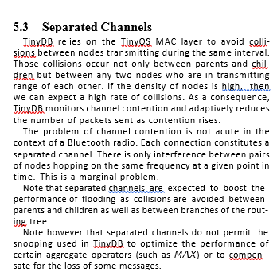

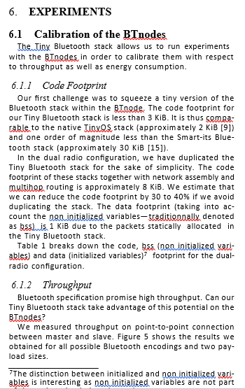

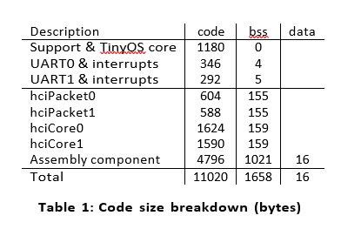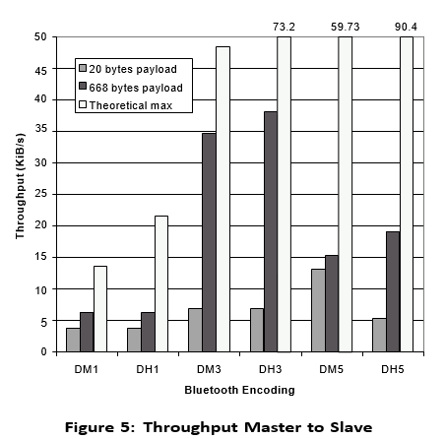

Bluetooth deﬁnes 6 encoding that correspond to the com- bination of two levels of resistance to noise (due to diﬀer- ent levels of redundancy in the encoding – DM: high resis- tance and DH: low resistance) and three conﬁgurations of the TDM scheme (the node transmits for 1, 3 or 5 time slots). The two payload sizes we consider are 20 bytes, i.e., enough to transport a few integers which is the case for many sensor network applications, and 668 bytes which is the maximum HCI packet size, i.e., enough to transport high bandwidth traﬃc such as images or sounds.

For payloads of 20 bytes, the encoding used does not make a signiﬁcant diﬀerence. We achieve a throughput of about 5 KiB/sec. For the maximum payload of 668 bytes, through- put is signiﬁcantly higher: it varies from 6 to 35 KiB/sec. Here, the number of slots used for transmission and the re- sistance to noise have a signiﬁcant impact. Our result shows that the best throughput is achieved with 3 slots transmis- sions (more data is transmitted than with 1 slot transmission and there is less retransmissions than with 5 slots).

Note that the throughput we achieve is far from the the- oretical max. First, our Tiny Bluetooth stack accesses the Bluetooth module via the UART and the maximum through- put supported by the UART is approximately 45 KiB/sec8. Second, the Bluetooth module generates superﬂuous mes- sages that take up bandwidth on the UART interface (hard- coded Ericsson string events).

Additional experiment have shown that slave to master communication achieves a throughput which is very similar to the master to slave communication shown in Figure 5. This means that data can ﬂow up the routing tree regardless of whether individual connections are master-slave or slave- master.

The master is responsible for allocating the channel band- width for each slave in a multipoint connection. We setup the master to connect to a number of slaves and send pack- ets in round-robin order on each connection. We measured the bandwidth on each connection. It would be expected that the total bandwidth stays the same and that each slave receives a fair share.

Table 2 shows that the aggregate bandwidth drops con- siderably but that each slave receives a fair share of that bandwidth. It is peculiar that the aggregate bandwidth drops as much as 50 %—the lower layers of Bluetooth allow the master to switch between slaves without any additional overhead. Hence the ROK modules wastes in-air slots by not sending meaningful data.

Madden et al. [12] write that it is reasonable to expect that the Mica motes transmit approximately 500 bytes per second. We thus achieve with the BTnodes a throughput, which is between one and two orders of magnitude higher for point-to-point connections and at the very least a factor of two for multipoint connections.

## Energy Consumption

The throughput results are encouraging; however energy consumption is the key metric for the calibration of the BTn- odes. We thus measured both current draw and voltage9 for diﬀerent regimes of our experimentation platform. Figure 6 summarizes our results.

Our ﬁrst goal was to measure energy consumption for an idle BTnode (in black on the ﬁgure). According to the man- ufacturer [1], the 8 MHz MCU can use up to 12 mA at 5 V (60 mW) in idle sleep mode. With a slightly lower clock frequency, we observe a lower energy consumption (about

8Note that we had to modify TinyOS to operate the UART at full speed. The UART relies on two registers for sending bytes: one, called the shift register, contains the byte cur- rently being sent, the other contains the byte to send next. We ﬁxed the UART module so that it generates an event each time the UART moves a byte to the shift register in- stead of generating an event each time the shift register is empty and the UART has no more data to send.

9We used an input voltage of approximately 5V. We ob- served that voltage varied slightly during the experiments. We thus decided not to assume constant voltage to compute the energy consumption.

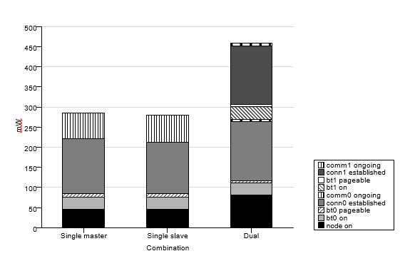

# Figure 6:

# Energy usage breakdown. The graph presents a master and a slave equipped with one radio (bt0) as well as a dual-radio node (with bt0 and bt1). In the legend, comm0 and comm1 denote connections established on bt0 and bt1 respectively.

46 mW). In the dual case, the base energy consumption is 80 mW. This is mostly due to the (unused but turned on) led on the BTtester, which consumes about 22 mW, as well as the voltage regulator and the serial voltage level converter. Turning a Bluetooth radio on consumes about 30 mW ex- tra (in idle mode). Making the radio pageable, or inquiriable requires an additional 9 mW. A BTnode with a single ra- dio waiting for a connection thus consumes 89 mW. In the dual radio case, turning on both radios and making them

pageable and inquirable consumes about 155 mW.

Nodes use about 136 mW to maintain connections. Addi- tional experiments showed that putting a connection in sniﬀ mode saves a marginal 5 mW. This suggests that some opti- mizations might have been missed in the Bluetooth module design.

Once a connection is established sending or receiving data consumes an additional 65 mW when transferring at 6 KiB/- sec when using a single radio and 5 mW for each radio when transferring 10 packets per second.

## Discussion

All in all, a single-radio BT node uses approximately 50 mW when idle and 285 mW when communicating, while these numbers are up to 80 and 450 mW for a dual-radio BT node. If we compare with the Mica motes from UC Berkeley, these numbers are high. Indeed, Madden et al. [12] report 10 mW for for an idle node and 60 mW when communicating.

The BTnodes consume ﬁve times more energy than the Mica motes doing nothing! This is due to the fact that the MCUs are placed in diﬀerent sleep modes. As we have seen with Tiny DB in Section 5.1, the Mica motes favour applications that manage themselves the time they spend in sleep mode. This way, the MCU can be put to sleep in *power save* mode, where only the external clock can send wake-up signals, i.e., the motes do not get data from sensors or from other nodes while the MCU is in sleep mode.

The *power save* sleep mode is the most energy eﬃcient.

The BTnodes favour applications that are in sleep mode until events are received from the Bluetooth radio or the sen- sors. This precludes the use of the *power save* mode because events generated by the Bluetooth radio would be ignored. The MCU is best put in *idle* sleep mode until an event is received from the UART or from the clock. The *idle* sleep mode is however less energy eﬃcient than the *power save* mode. We can estimate to 8 days the life expectancy of a BTnode in *idle* sleep mode with two standard AA batteries. We noted that energy consumption was high when trans- mitting data. However, if we consider the ratio energy per bit transmitted, then the BTnode exhibits rather good performances Running at 6 KiB/s, we obtain approxi- mately 5.5 *µ*J/bit for a single radio and 10 *µ*J/bit for two radios. These numbers are close to the ones reported in the original TinyOS paper [9] (approximately 4 *µ*J/bit) for an ideal transmission without interference or loss. According to Madden et *µ*J/bit

Another characteristics of these results is that connection maintenance consumes a lot of energy, both on master and slave. Using the sniﬀ mode does not make a signiﬁcant dif- ference. These results suggest that connections should only be established for short periods. There is thus a trade-oﬀ between the cost of connection maintenance and the cost of network assembly. We explore this trade-oﬀ in the next Section.

In summary, all these remarks suggest that the BTnodes are well suited for applications that are active over a limited time period, with few unpredictable bursts of very heavy network traﬃc (taking advantage of the high throughput). An example of such application could be a sensor network deployed to secure a building in a mounted operation in urban terrain. Such a network could have a life expectancy of up to a week, operating in sleep mode until individuals are detected in which case as much situational information as possible could be obtained (including possibly images or sound on a suite of point-to-point connections).

# Network Self-Assembly

Because it is expensive to maintain a connection it is likely that the network will be assembled repeatedly when data needs be transmitted. Network assembly should thus be rapid and energy eﬃcient.

Figure 7 shows energy consumption as a function of time on a BTnode during network assembly. The ﬁgure is anno- tated with letters corresponding to the diﬀerent phases of the experiment. As the node is turned on (a), it initializes its *slave* radio. After a while, it discovers its parent-to-be, connects to it (b) and enables its *master* radio that becomes discoverable. The connection is established within 20 sec- onds.

For the sake of clarity, we turn on the children nodes one after the other. After 30 seconds, the ﬁrst child is turned on, it is detected and a connection is established on the node’s *master* radio (c). After 40 second, the second child is turned on and a second connection is established (d). Energy con- sumption corresponds to the calibration presented in the previous Section. Additional connections result in a very limited increase in energy consumption (about 3-4 mW).

Once those connections are established, the node routes data from both children to its parent: both children send packets with payload of 5 and 50 bytes every 10 seconds for a 100 seconds. Note that the children do not send in synch. The peaks of energy consumption we observe from 40 seconds until 160 seconds correspond primarily to the master

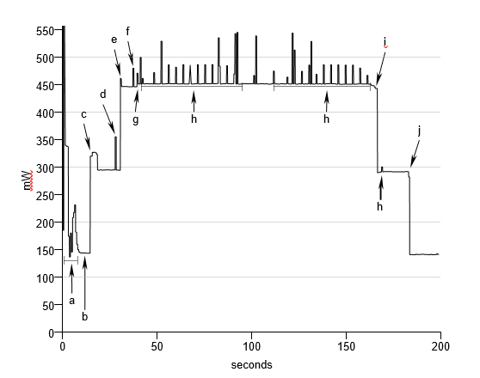

# Figure 7: Energy Usage during Network Assembly

**and Transmissions**

radio being discoverable (e) and also to the transmission of data packets (f)10.

After 160 seconds, both children are disconnected (g) and after 180 seconds the parent is disconnected (h). The node remains idle with both Bluetooth radios disabled but pow- ered on.

Additional experiments show that our assembly procedure requires in most cases between 5 and 10 seconds per level in the connection tree assuming all nodes have already initial- ized their Bluetooth radios11. Indeed, children can only be discovered once the connection to the parent is established. Energy consumption corresponds to what could be pre- dicted after calibrating the nodes. There is no extra over- head introduced by the assembly procedure. In order to save energy, it thus seems a good idea to assemble the network repeatedly, for relatively short periods during which high

volumes of data can be transmitted.

**BLUETOOH BASED SENSOR NETWORKS**

* Challenge: It is to ensure interoperability among various Bluetooth manufactures’ devices and to provide numerous applications.
* One such application is : WIRELESS SENSOR NETWORKS (WSN)
* Important features of WSN: *Collaboration of network nodes during execution* and *Data Centric nature.*
* Many smart sensor nodes scattered in the field collect data and send it to users via ‘gateway’ using *multi−hop routes.*

## WIRELESS SENSOR NETWORKS (WSN)

WSN consists of number of small devices equipped with a *sensing unit, microprocessors, wireless communication interface* and *power source.*

Two main operations performed by WSN are:

1. QUERING − Queries are used when user requires only the current value of the observation.
2. TASKING − More Complex operation

Used when a phenomenon has to be observed over a large period of time.

**Functions of GATEWAY:**

* **Communication with sensor networks** *:* Shortage Wireless Communication ; Discovery of smart sensor nodes
* **Gateway Logic***:* Controlling Gateway interface and data flow ; Providing uniform access to sensor
* **Communication with users***:* Communication over Internet, WAN, Satellite, etc.

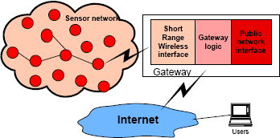

**Figure**: Wireless Sensor Network

## DISCOVERY OF SMART SENSOR NODES

* After installation, the primary step during execution is to discover the smart sensor nodes in the area.
* The is to prepare a list of sensor’s characteristics and network topology.
* Next in execution process, provision is to have addition of new or removal of existing sensors.

## ALGORITHM FOR OPERATION OF NETWORKS

* Initialization of gateway and Bluetooth Inquiry Procedure.
* Discovery of Bluetooth device and Checking of major and minor devices.
* Setting of parameters and assigning type of devices and sensors.
* Description by Service−Class Field.
* Discarding of non−smart nodes.
* Else, service database of the discovered smart node is searched for sensor services.
* If no current sensor profile, then database is searched for serial port connection parameters.
* Lastly, Bluetooth link is established and data exchange with smart node starts.

## SENSOR NETWORK IMPLEMENTATION

* OBJECTIVE: To build a Hardware plat form and generic Software Solutions to serve for research in WSN protocols.
* Components of Sensor Network: *Smart Sensor Nodes* and *Gateway*
* Gateway and Smart nodes are members of *piconets* and so, not more than 7 nodes can exist in the network.

#### Example: Pressure Sensor

For implementation of Pressure Sensor as Bluetooth Node, following components are important:

* Bluetooth Device
* Sensors
* Microcontroller
* TEDS − Transducer Electronic Data Sheet

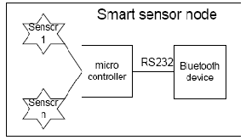

Figure: SMART SENSOR NODE IMPLEMENTATION

**Wireless connectivity over Bluetooth:**

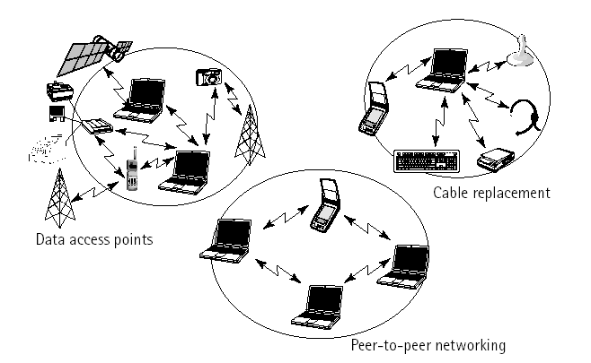

The basic function is to provide a standard wireless technology to replace the multitude of propriety cables currently linking computer devices. Better than the image of the spaghetti-free computer system is the ability of the radio technology to the network when away from traditional networking structures such as business intranet.for, example imagine being on a business trip with a laptop and a phone. The Bluetooth technology allows interfacing the two. Then picture meeting a client and transferring files without cabling or worrying about protocols. That is what the Bluetooth will do.

**Network arrangement:**

Bluetooth network arrangements can be either point-to-point or point-to-multipoint. The various network arrangements regarding Bluetooth are:

* + - a) Single-slave
    - b) Multi-slave(up to 7 ‘Slaves’ on one master)
    - c) Scatternet

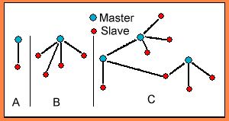

**Bluetooth:**

Bluetooth has been designed to operate in a noisy radio frequency environment, and uses a fast acknowledgement and frequency-hopping scheme to make link robust, communication wise. Bluetooth radio modules avoid interference from other signals by hopping to a frequency after transmitting or receiving a packet. Thus, Bluetooth modules use Frequency-Hopping Spread Spectrum (FHSS) techniques for voice and data transmission. Compared with other systems operating in the same frequency band, Bluetooth radio typically hops faster and uses shorter packets.

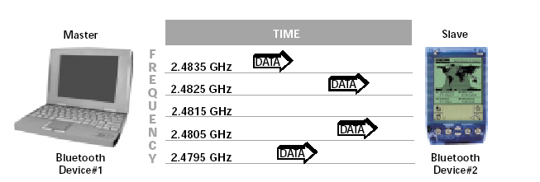

SS uses packet-switching to send data from the transmitter of one Bluetooth module to the receiver of another. Unlike circuit-switching which establishes a communication link on a certain frequency (channel), FHSS breaks the data down into small packets and transfers it on a wide range of frequencies across the available frequency band. Bluetooth transceivers switch or “hop” among 79 hop frequencies in the 2.4 GHz band at a rate of 1,600 frequency hops per second.

**Bluetooth – “Simply the Best!”:**

Bluetooth competes with existing technologies like IrDA, WLAN and Home RF. IrDA is not omni directional and it is a line-of-sight technology. WLAN’s are essentially ordinary LAN-protocols modulated on carrier waves, while Bluetooth is more complex. HomeRF is a voice and data home networking which operates at a low speed. Bluetooth hops very fast (1600 hops/second) between frequencies, which does not allow for long data blocks. These problems are overcome in Bluetooth and that’s why Bluetooth is considered “Simply the Best”.

#### Blue TOOTH BASED sensor NETWORK

The main challenge in front of Blue tooth developers now is to prove interoperability between different manufactures’ devices and to provide numerous interesting applications. One of such applications is a wireless sensor network.

Wireless sensor networks comprise number of small devices equipped with a sensing unit, microprocessors, and wireless communication interface and power source.

1. An important feature of wireless sensor networks is collaboration of network nodes during the task execution.
2. Another specific characteristics of wireless sensor network is Data-centric nature.

As deployment of smart sensor nodes is not planned in advance and positions of nodes in the field are not determined, it could happen that some sensor nodes end in such positions that they either cannot perform required measurement or the error probability is high. For that a redundant number of smart nodes is deployed in this field. These nodes then communicate, collaborate and share data, thus ensuring better results.

Smart sensor nodes scattered in the field, collect data and send it to users via “gateway” using multiple hop routes.

Short range wireless interface

Gate way logic

Public network

interface

Internet

sensor network

Users

A Wireless sensor network

##### **The main functions of a gateway are**

##### **Communication with sensor Networks**

* + Shortage wireless communication is used.
  + It provides functions like discovery of smart sensor nodes, generic methods of sending and receiving data to and from sensors, routing.

##### **Gateway logic**

* + It controls gateway interfaces and data flow to and from sensor network.
  + It provides an abstraction level that describes the existing sensors and their characteristics.
  + It provides functions for uniform access to sensors regardless of their type, location or N/W topology, inject queries and tasks and collect replies.

##### **Communication With Users**

* + Gateway communications with users or other sensor networks over the Internet, WAN, Satellite or some shortage communication technology.

From the user point of view, querying and tasking are two main services provided by wireless sensor networks. Queries are used when user requires only the current value of the observed phenomenon. Tasking is a more complex operation and is used when a phenomenon has to be observed over a large period of time. Both queries and tasks of time to the network by the gateway, which also collects, replies and forwards them to users.

#### sensor NETWORK implementation

The main goal of the implementation was to build a hardware platform and generic software solutions that can serve as the basis and a test bed for the research of wireless sensor network protocols.

Implemented sensor network consists of several smart sensor nodes and a gateway. Each smart node can have several sensors and is equipped with a micro-controller and a Bluetooth radio module.

Gate way and smart nodes are members of the Piconet and hence maximum seven smart nodes can exist simultaneously in the network.

For example, a pressure sensor is implemented, as Bluetooth node in a following way.

The sensor is connected to the Bluetooth node and consists of the pressure-sensing element, smart signal-conditioning circuitry including calibration and temperature compensation, and the Transducer Electronic Data Sheet (TEDS). These features are built directly into the sensor microcontroller used for node communication control plus memory for TEDS configuration information.

#### Smart Sensor Node Architecture

The architecture shown in figure can easily be developed for specific sensor configurations such as thermocouples, strain gauges, and other sensor technologies and can include sensor signal conditioning as well as communications functions.

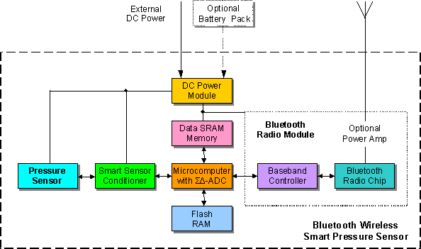

**A Bluetooth wireless smart pressure sensor node**

Conditioned along sensor signal is digitized and digital data is then processed using stored TEDS data. The pressure sensor node collects data from multiple sensors and transmits the data via bluetooth wireless communications in the 2.4 GHZ base band to a network hub or other internet appliance such as a computer.

The node can supply excitation to each sensor, or external sensor power can be supplied. Up to eight channels are available on each node for analog inputs as well as digital output. The sensor signal is digitized with 16-bit A/D resolution for transmission along with the TEDS for each sensor. This allows each channel to identify itself to the host system. The node can operate from either an external power supply or an attached battery. The maximum transmission distance is 10 meters with an optional capability to 100 meters.

The IEEE 1451 family of standards are used for definition of functional boundaries and interfaces that are necessary to enable smart transducer to be easily connected to a variety of networks. The standards define the protocol and functions that give the transducer interchangeability in networked system, with this information a host microcomputer recognized a pressure sensor, a temperature sensor, or another sensor type along with the measurement range and scaling information based on the information contained in the TEDS data.

With blue tooth technology, small transceiver modules can be built into a wide range of products including sensor systems, allowing fast and secure transmission of data within a given radius (Usually up to 10m).

A blue tooth module consists primarily of three functional blocks – an analog 2.4 GHz., Blue tooth RF transceiver unit, and a support unit for link management and host controller interface functions.

The host controller has a hardware digital signal processing part- the Link Controller (LC), a CPU core, and it interfaces to the host environment. The link controller consists of hardware and software parts that perform blue tooth based band processing, and physical layer protocols. The link controller performs low-level digital-signal processing to establish connections, assemble or disassemble, packets, control frequency hopping, correct errors and encrypt data.

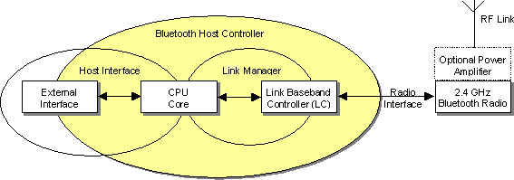

Bluetooth module Hardware Architecture

The CPU core allows the blue tooth module to handle inquiries and filter page request without involving the host device. The host controller can be programmed to answer certain page messages and authenticate remote links. The link manager(LM) software runs on the CPU core. The LM discovers other remote LMs and communicates with them via the link manager protocol (LMP) to perform its service provider role using the services of the underlying LC. The link manager is a software function that uses the services of the link controller to perform link setup, authentication, link configuration, and other protocols. Depending on the implementation, the link controller and link manager functions may not reside in the same processor.

Another function component is of course, the antenna, which may be integrated on the PCB or come as a standalone item. A fully implemented blue tooth module also incorporates higher-level software protocols, which govern the functionality and interoperability with other modules.

Gate way plays the role of the Piconet’s master in the sensor network. It controls establishments of the network, gathers information about the existing smart sensor nodes and sensor attached to them and provides access to them.

Discovery Of The Smart Sensor Nodes

Smart sensor node discovery is the first procedure that is executed upon the gateway installation. It goals to discover all sensor nodes in the area and to build a list of sensor’s characteristics and network topology. Afterwards, it is executed periodically to facilitate addition of new or removal of the existing sensors. The following algorithm is proposed.

When the gateway is initialized, it performs bluetooth inquiry procedure. When the blue tooth device is discovered, the major and minor device classes are checked. These parameters are set by each smart node to define type of the device and type of the attached sensors. Service class field can be used to give some additional description of offered services. if discovered device is not smart node it is discarded. Otherwise service database of the discovered smart node is searched for sensor services. As currently there is no specific sensor profile, then database is searched for the serial port profile connection parameters. Once connection strings is obtained from the device. Blue tooth link is established and data exchange with smart mode can start.

# A WIRELESS SENSOR NETWORK

Wireless sensor network provides two important actions querying and tasking.

**Querying**: When there is need of current value of observed event, queries are used.

**Tasking**: It is more composite operation and is useful when an event needs to be noticed for a long time.

These two services querying and tasking are allocated to the system through “gateway” which also forwards the collected responds to users.

The main functions of a gateway are

* + Interaction with sensor networks.
  + Short wireless transmission is used.
  + It contributes functions like finding of smart sensor nodes
  + Provides techniques of sending and receiving data from sensors, routing.
  + It controls gateway attachment and dataflow to and from sensor network.
  + It provides standard of dealing with ideas that gives detail about the current participating sensors and their characteristics.
  + It allocates function for consistent approach to sensors without being affected by their type, location or network topology, introduce queries and tasks and gather respond.
  + Communication with Users.
  + Gateway communication with user and another sensor networks through the internet, WAN, Satellite or other short communication technology.

## SENSOR NETWORK IMPLEMENTATION

The main target of the sensor network execution was to construct a hardware plan and common software answers that can works as support and for the motive of research in wireless sensor network agreement.

Implemented sensor networks involve smart sensor nodes and a gateway. Every node has countless sensors and is connected with microcontroller and Bluetooth element.

Gateway and smart nodes behave as the part of the Piconet. For example: A Bluetooth pressure sensor.

The sensor is attached on the Bluetooth node. It has the pressure feeling element, smart signal-conditioning circuitry containing density and temperature reception, and the Transducer Electronic Data Sheet (TEDS). These are integral features of sensor microcontroller which are used for node communication control and also for the memory for TED’s arrangement .

## SMART SENSOR NODES DISCOVERY

For the execution for the gateway installation the first step is the locating of the smart sensor nodes. With the help of gateway, all the smart nodes are found and build the list of the attribute of sensors and network topologies. After that for making the process easy for the removal of existing sensor and addition of the new it is executed concurrently.

**ALGORITHM**:

After the initialization of gateway is done, Bluetooth performs the inquiry procedure. Major and minor device classes are checked after the detection of the Bluetooth devices. Some parameters are set by the sensor nodes for defining the type of device and type of attached sensor. To give some further explanation of offered service, the duty class field is used . And if the founded device is not a smart node then it is disposed. As there is no particular sensor profile at ongoing time, the database is hunt for the serial port outline link. Once interrelated string is acquired then the Bluetooth link is accepted and the transfer of the data is started.

# ADVANTAGES

* + Inexpensive.
  + Low Power utilization.
  + Small range.
  + Wireless Technology.
  + Sensible throughput.
  + Cheap maintenance cost.
  + Easy link formation.
  + Share voice and data.

# LIMITATIONS

* + Low data range.
  + Interference with other device.
  + Low security.
  + Low data rate.

# CONCLUSION

Wireless sensor networks are fascinating research area with multi feasible applications and with many solutions. They are combination of various tiny devices having the ability of interacting and dealing with data. Bluetooth is an easy and suitable option for data communication in sensor networks [6]. To plan routing and application-level procedures, we overlook multiple affairs related to MAC layer, physical layer, application layer and routing layer [1]. For the automatic link up and information exchange, the Bluetooth devices need to bring within the range of another device.

Our experiments with the BTnodes suggest that Blue- tooth based sensor nodes could be appropriate for a niche of applications exchanging unpredictable bursts of data during a limited time period. It is diﬃcult to predict that Bluetooth will emerge as an alternative of choice for a larger class of sensor network ap- plications. First, as long as scatternets are not supported we will have to rely on a dual-radio approach which is ex- pensive and energy ineﬃcient. Second, using Bluetooth for commercial purpose requires a certiﬁcation (to guarantee that heterogeneous devices can communicate) which is ir- relevant and unrealistic in the context of sensor networks. Third, the encapsulation of the three lower layers on hard- 10A similar experiment without data transmission also ex- hibits energy peaks but with a more regular intensity. 11We observe that connections take most of the time 5 to 10 seconds with some outliers requiring 20 to 30 seconds. We have studied the characteristics of device discovery and connection establishment in previous

# APPLICATIONS:

* + Constant sensing
  + Health monitoring
  + Event detection & local control of actuators
  + Smart buildings
  + Smart grid and energy control system
  + Environmental monitoring
  + Military and security & surveillance
  + Industrial safety
  + Home, & other commercial areas.

# REFERENCES

1. Mark Weiser, “The Computer for the Twenty-First Century”, Scientific American, 1991.
2. Wireless World Research Forum, “Book of Visions”, [http://www.wireless-world-research.org](http://www.wireless-world-research.org/)
3. Scenarios for Ambient Intelligence, EU IST Advisory Group
4. H. Gharavi and K. Ban, “Video-based multihop ad-hoc sensor network design,” in Proc.WorldWireless Congress, San Francisco, CA, May 2002, pp. 469–474.
5. J. M. Kahn, R. H. Katz and K. S. J. Pister, "Mobile Networking for Smart Dust", ACM/IEEE Intl. Conf. on Mobile Computing and Networking (MobiCom 99),

Seattle, WA, August 17-19, 1999.

1. G.J. Pottie, W.J. Kaiser, “Wireless Integrated Network Sensors”, Communications of the ACM, May 2000, Vol. 43, No. 5
2. J.M. Rabaey, M.J. Ammer, J.L. da Silva Jr., D. Patel, S. Roundy, “PicoRadio Supports Ad Hoc Ultra-Low Power Wireless Networking", IEEE Computer Magazine, July 2000
3. J. Hill, R. Szewczyk, A. Woo, S. Hollar, D. Culler, K. Pister, “System Architecture Directions for Networked Sensors”, Proceedings of the ASPLOS 2000

# REFERENCES

1. Mark Weiser, “The Computer for the Twenty-First Century”, Scientific American, 1991.
2. Wireless World Research Forum, “Book of Visions”, [http://www.wireless-world-research.org](http://www.wireless-world-research.org/)
3. Scenarios for Ambient Intelligence, EU IST Advisory Group
4. H. Gharavi and K. Ban, “Video-based multihop ad-hoc sensor network design,” in Proc.WorldWireless Congress, San Francisco, CA, May 2002, pp. 469–474.
5. J. M. Kahn, R. H. Katz and K. S. J. Pister, "Mobile Networking for Smart Dust", ACM/IEEE Intl. Conf. on Mobile Computing and Networking (MobiCom 99),

Seattle, WA, August 17-19, 1999.

1. G.J. Pottie, W.J. Kaiser, “Wireless Integrated Network Sensors”, Communications of the ACM, May 2000, Vol. 43, No. 5
2. J.M. Rabaey, M.J. Ammer, J.L. da Silva Jr., D. Patel, S. Roundy, “PicoRadio Supports Ad Hoc Ultra-Low Power Wireless Networking", IEEE Computer Magazine, July 2000
3. J. Hill, R. Szewczyk, A. Woo, S. Hollar, D. Culler, K. Pister, “System Architecture Directions for Networked Sensors”, Proceedings of the ASPLOS 2000